This page of the notebook will go over how to use EJS to create templates with ExpressJS. You may have to reference parts of the first and second pages of the Notebook to complete this tutorial.

1. 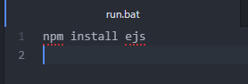Create a project folder relevant to EJS, initialize a Node.js project, and install expressJS.
2. 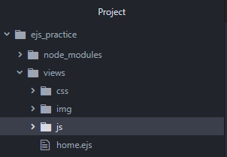Using either a batch file or the CMD Prompt run the command: “npm install ejs”.
3. Create a folder named “views” in the main project folder. In it, make a new file named “home.ejs” and three folders: css, img, and js.
4. Text

   Description automatically generatedIn the home.ejs file, start an HTML page. You may customize this however you want but it is best to keep it simple! *(note: this is how mine looked like in the end)*
5. 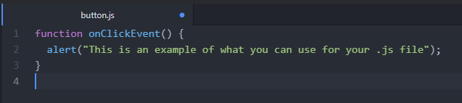Text

   Description automatically generatedPlace whatever image you want in the /img folder. The /js folder should contain something simple like script for an onclick event. In the /css folder, start working on a stylesheet; I suggest formatting the image or heading to make it fit the page. Try something like this:
6. 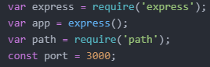In the main project folder - create a .js file and start by setting up a basic ExpressJS page.
7. 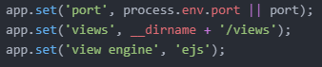Next, use app.set for ‘views’ and to set EJS as the templating engine.
8. Text

   Description automatically generatedThe app.use function must be used so that you can manipulate all files from the /views directory.
9. 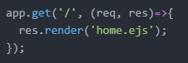Once you do this, you are ready to make use of the “app.get” function - in brackets, type “res.render()” and input the name of the .ejs file. This will request the file’s data and allow the page to open when you run the server.
10. 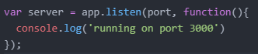Last, you must create the “server” variable where it will listen in on the port you declared earlier. Use “console.log” and in quotations type something along the lines of “running”. I recommend running your server now and seeing what it looks like.
11. Text

    Description automatically generatedTo create a template, in the /views directory, create a file named “template.ejs”. Create a regular html file and link the stylesheet. In the body, we can put “<%- “to use.
12. Text

    Description automatically generatedIn the main .js file we can change the render() to render the template itself.
13. When you run the server and go to your localhost – you should see something like this.

